**Assignment -3**

Python Programming

|  |  |
| --- | --- |
| Assignment Date | 11 October 2022 |
| Student Name | S. Vijaya Rama Lakshmi |
| Student Roll Number | 953719106043 |
| Maximum Marks | 2 Marks |

**Question-1:**

Image Augumentation

|  |
| --- |
| **Solution:** |
|  |
|  |
|  |
|  |
|  |
|  |
|  |
|  |
|  |
|  |
|  |

**Question-2:**

Create Model

|  |
| --- |
| **Solution:** |

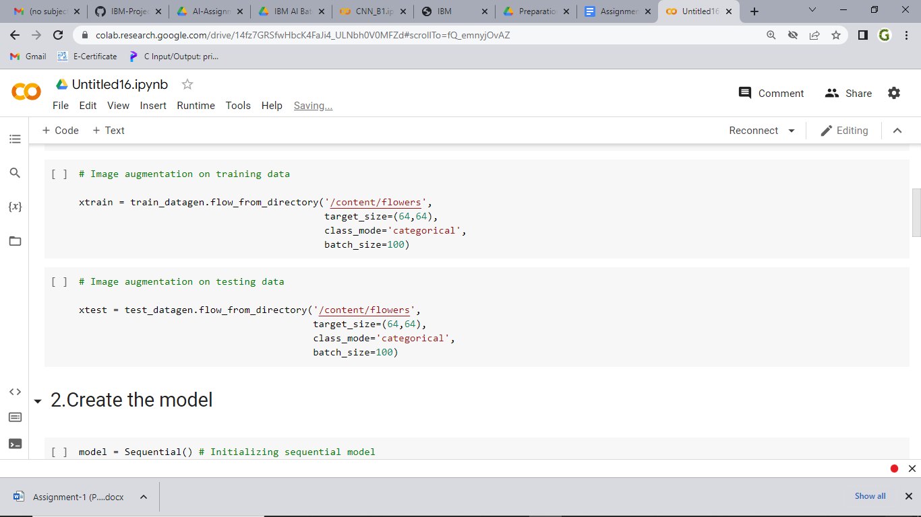

**QUESTION -3**

Add Layers (Convolution,MaxPooling,Flatten,Dense-(Hidden Layers),Output)

**Solution:**

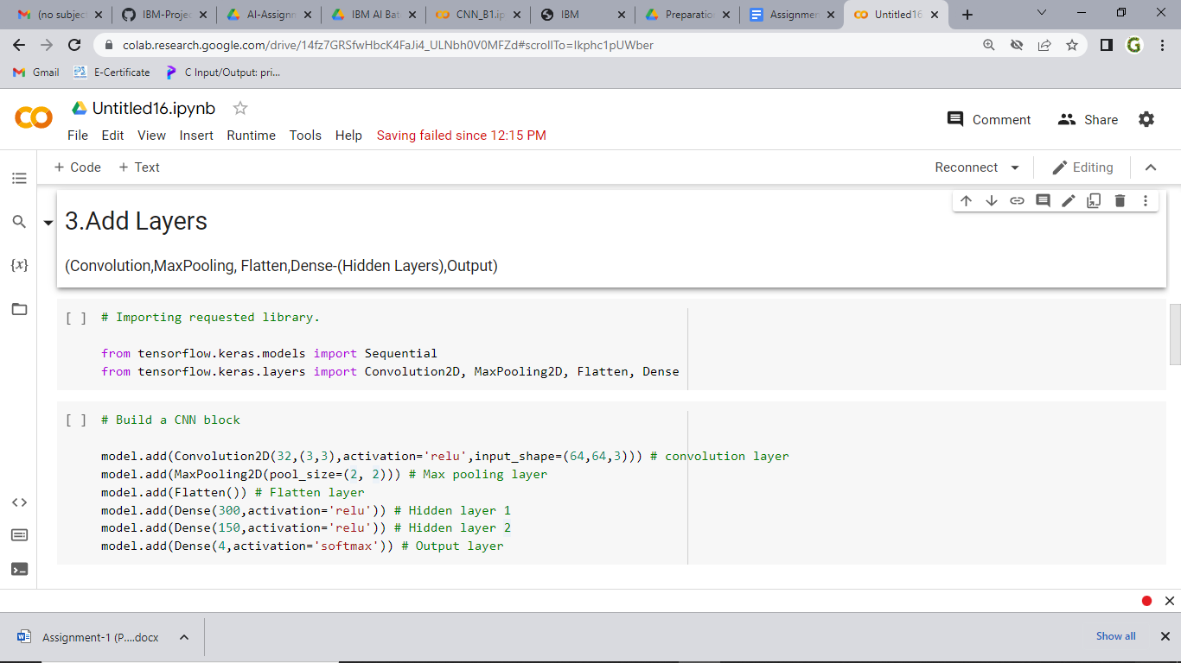

**QUESTION-4**

Compile the model

**Solution:**

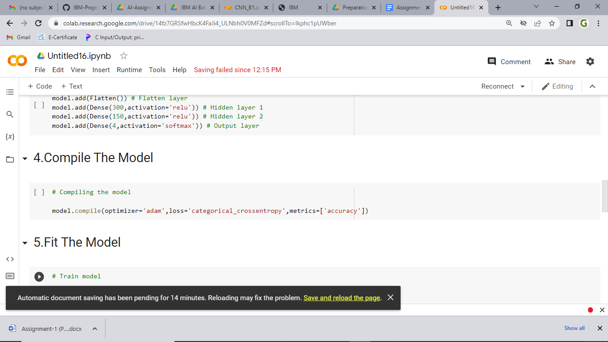

**QUESTION-5**

Fit the model

**Solution:**

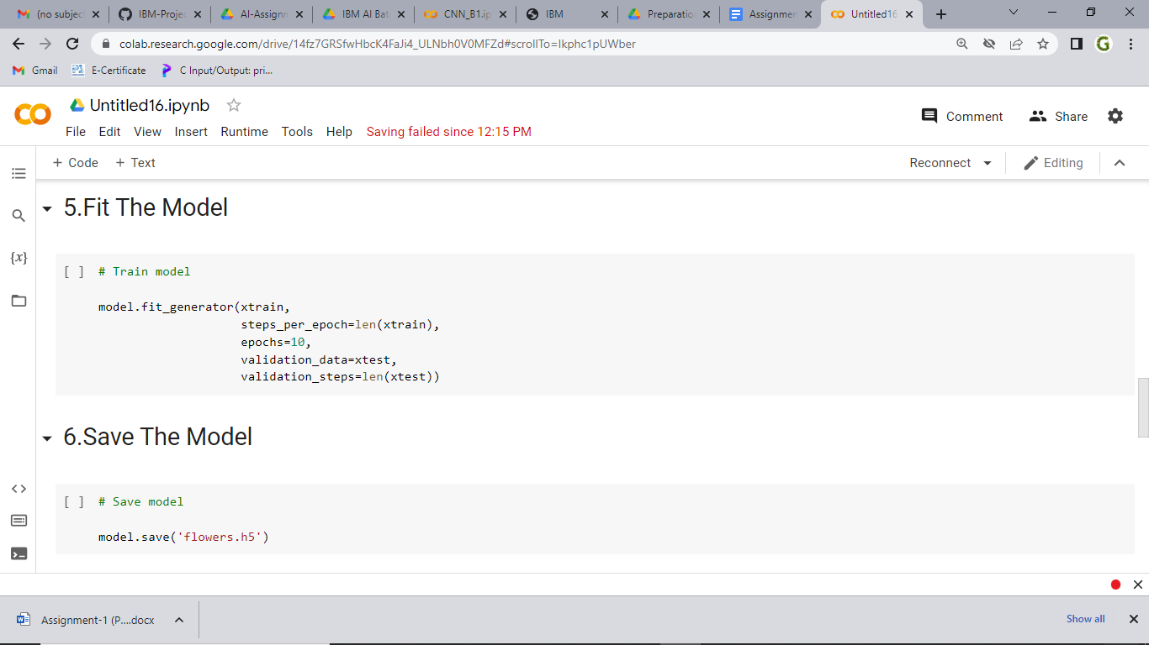

**QUESTION-6**

Save the model

**Solution:**



**QUESTION -7**

Test the model

**Solution:**

